Buan 6312.003

Econometrics and time series analysis

Helton, Lisa

Yadav, Ekta

Banda, Sanjana

Shukla, Paritosh

Ghani, Ashik

Introduction:

We analyze on the Guns data to address the following question, “**Do more guns and /or higher incarceration reduce crime?”.** The analysis can provide some insights on the statistics behind the effect of Shall – carry law and Incarceration rate on the crime rate in the United States across the years (1977-1999).

Shall-issue law

Many states in the United States have passed **right-to-carry laws** (also known as shall-issue laws). A Shall-issue law is one that requires that governments issue concealed carry handgun permits to any applicant who meets the necessary criteria. These criteria are that the applicant must be an adult, have no significant criminal record and no history of mental illness and successfully complete a course in firearms safety training (if required by law). If these criteria are met, then the granting authority has no discretion in the awarding of the license.

Firstly, we started looking at the variables and their impact on the crime rate is as follows:

According to us,

1. Shall Law: The Shall law will have a negative effect on overall crime rate which means if a state has or adopted Shall law, the crime rate will go down.
2. Incarceration rate (incarc_rate): If the incarceration rate increases then it will result in decreased crime rate.
3. Density: If the density increases then the crime rate will also increase.
4. Average Income (avginc): If the average income increases then the crime rate will decrease as people with less income or unemployed will be involved in more crimes.
5. Population (pop): With increase in population the crime rate will also increase.
6. Population of Male under age range 10 to 29 years(pm1029): According to us, if pm1029 increases then it will result in increased crime because the youth are more involved in crime.
7. Population of White under age range 10 to 64 years(pw1064): According to us, It would not affect the crime rate in a significant way.
8. Population of Male under age range 10 to 64 years(pm1064): If the population of black increases, the crime rate will increase. Note: we are setting aside the assumption of racial discrimination while giving this statement.

Data Description

Balanced Panel Data

No. of entities – 51

Time interval – 1977 - 1999

No. of observations – 1173

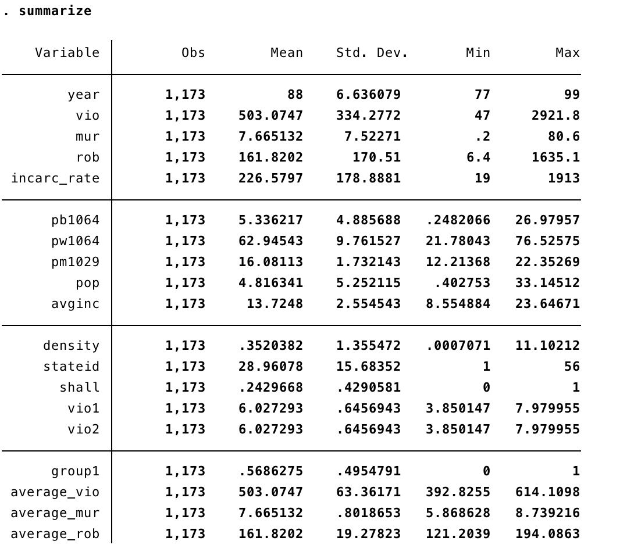

Exploratory Analysis

We started with the Data exploration to better understand the relationship between the various variables. Let’s first investigate how the violent crime rate, robbery rate and murder rate have changed between 1977 and 1999.

DISTRIBUTION OF CRIME RATES ACROSS YEARS (1997-1999)

A screenshot of a cell phone

Description generated with high confidence

A close up of text on a white background

Description generated with high confidence

A close up of a map

Description generated with very high confidence

We can see that, while there has been some fluctuation in the rates, the crime rate for all three categories started dropping rapidly after 1993. What is the reason for this sudden drop? Let's first investigate how shall-carry laws have changed throughout the years.

EFFECT OF SHALL-CARRY LAW ON CRIME RATE

A screenshot of a cell phone

Description generated with high confidence

We can see a surge in the number of states that have active shall-carry laws during the 90's. This could explain the drop in average crime rate after 1993. Let us explore further to find more evidence to support it.

DISTRIBUTION OF SHALL-CARRY LAW (BEFORE AND AFTER INTRODUCTION)

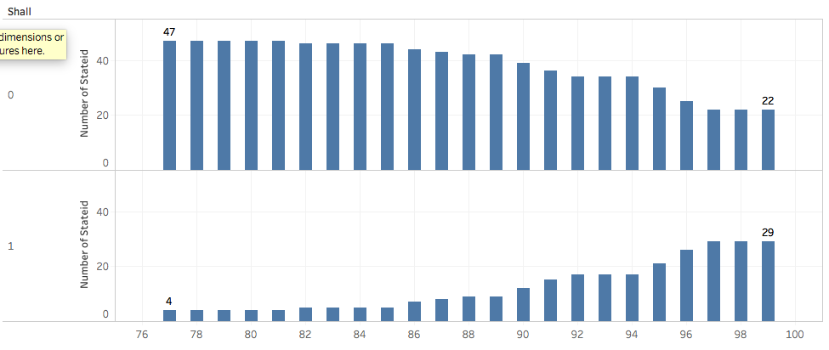

Shall (0) – Shall issue law has not been implemented

Shall (1) – Shall issue law has been implemented

From the above graph we can see the distribution of shall 0 and shall 1. We can say that there has been an upward trend in adopting the shall law from year 1977 to 1999.

The number of states that adopted shall law in year 1977 is 4, which has increased to 29 states in the year 1998

STATE ID WITH NO SHALL-CARRY LAW (1977-1998) – TABLE A

STATE ID WITH SHALL-CARRY LAW (1977-1998) – TABLE B

STATE ID NO SHALL LAW TO SHALL-CARRY LAW (1977-1998) – TABLE C

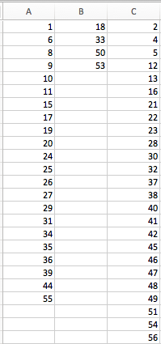

To find out if the drop in the average crime rate after 1993 is due to adoption of shall-carry law, let’s observe the distribution for the states in table(C), which have changed from no shall-carry law to adoption of shall-carry law. The below graphs depict the distribution of

-Murder rate (red line)

-Violent crime rate (green line)

-Robbery rate (blue line)

for the year before the shall law adoption, during the year of shall law adoption and year after the shall law was adopted.

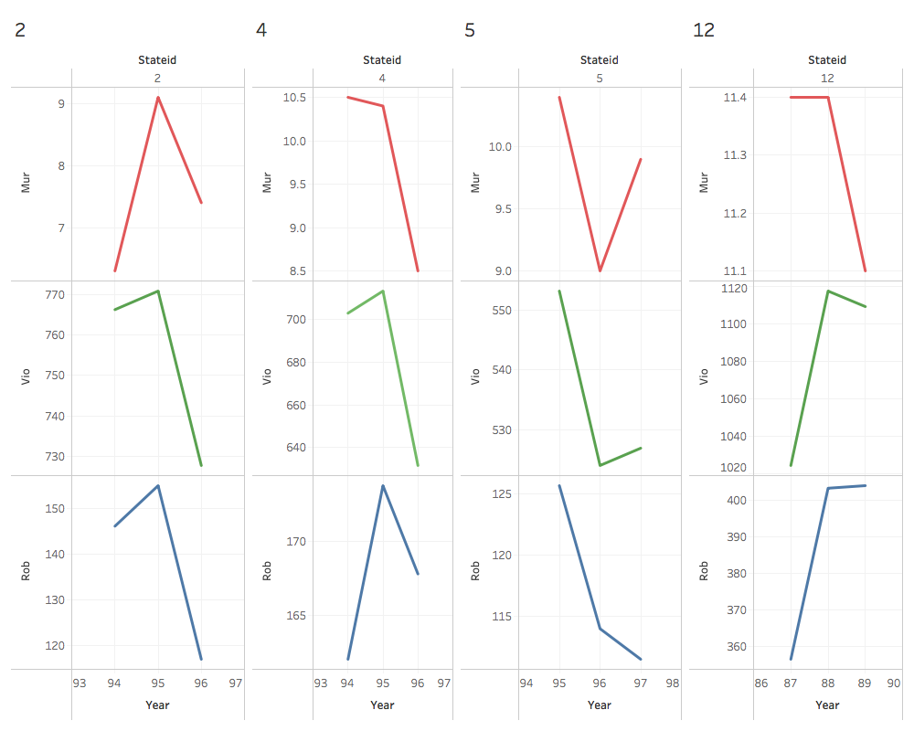 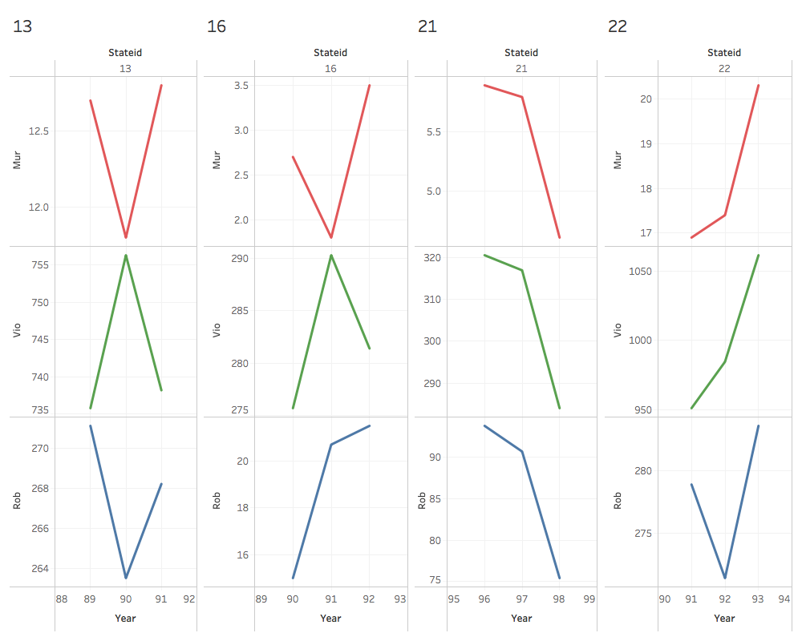

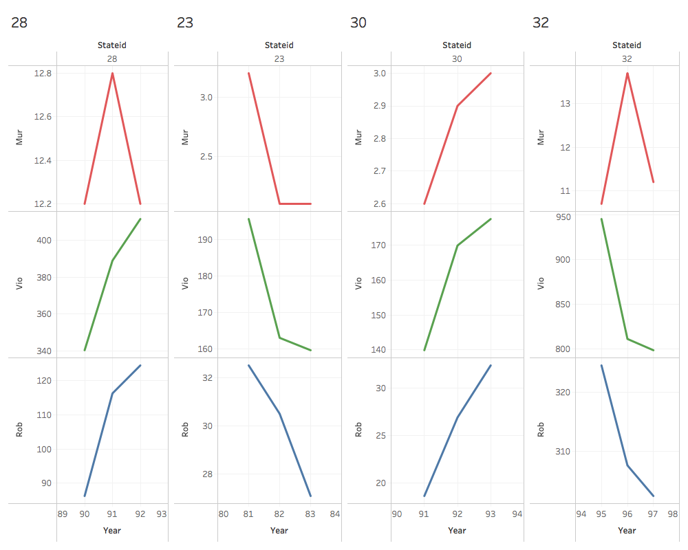 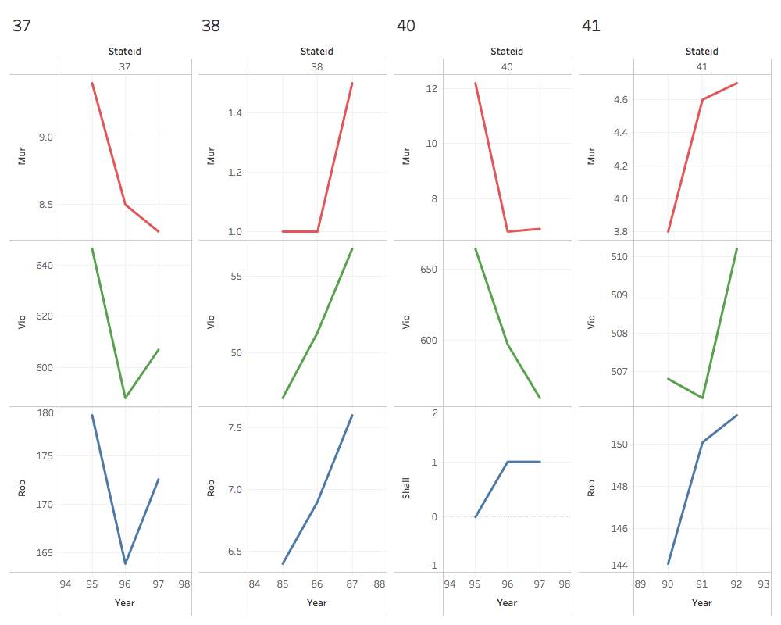

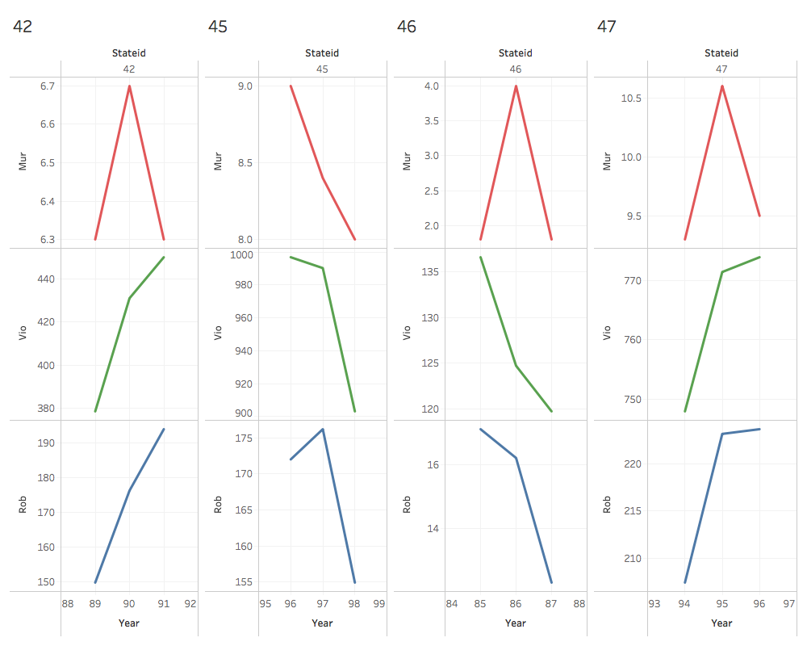 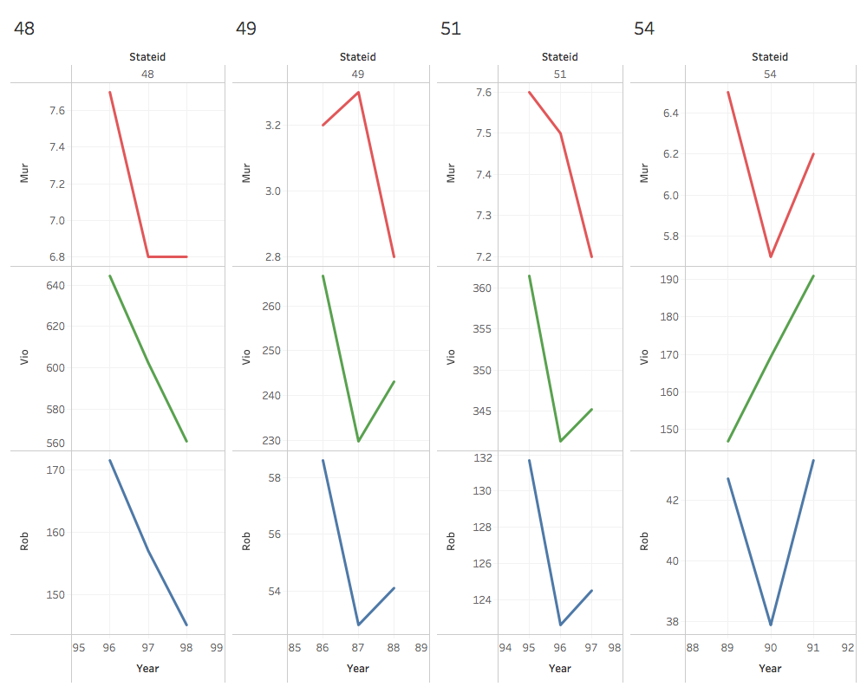

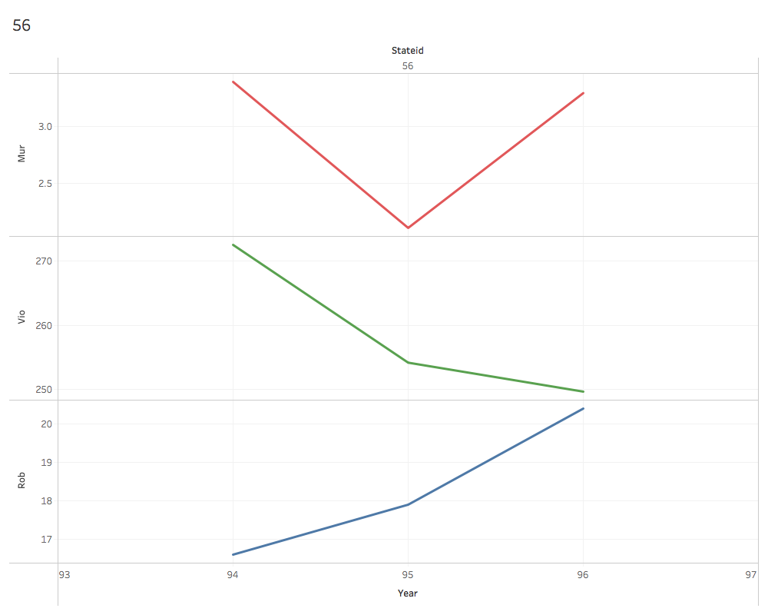

We see there is no constant trend, not necessarily the murder rate, violent crime rate or the robbery rate has seen a decline in the immediate years after the adoption of shall issue law.

We can further observe the behavior of the shall-carry law on crime rate in our model outputs.

Let’s explore more variables and see how they are associated with the crime rates.

Average Murder rate, Violent Crime rate and Robbery rate across 51 states in the years (1977-1999)

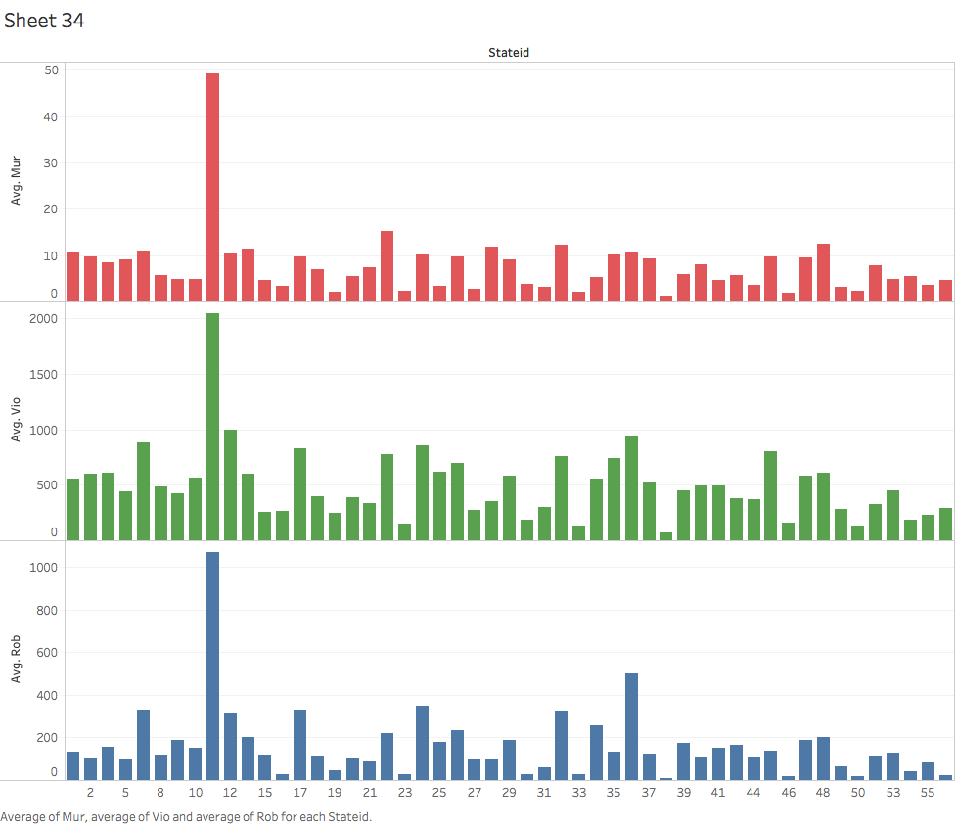

We observe that State 11 has the highest crime rate among all other 51 states in the year (1977-1999). What could be the possible reasons for highest crime in state 11?

Average Murder rate, Violent Crime rate and Robbery rate trend over the years (1977-1999) for all 51 states

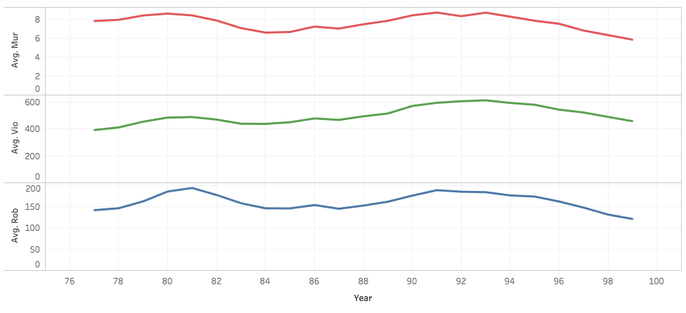

We don’t observe any regular trend of the crime rates over the years of (1977- 1999).

STATE ID Vs AVERAGE % OF STATE POPULATION

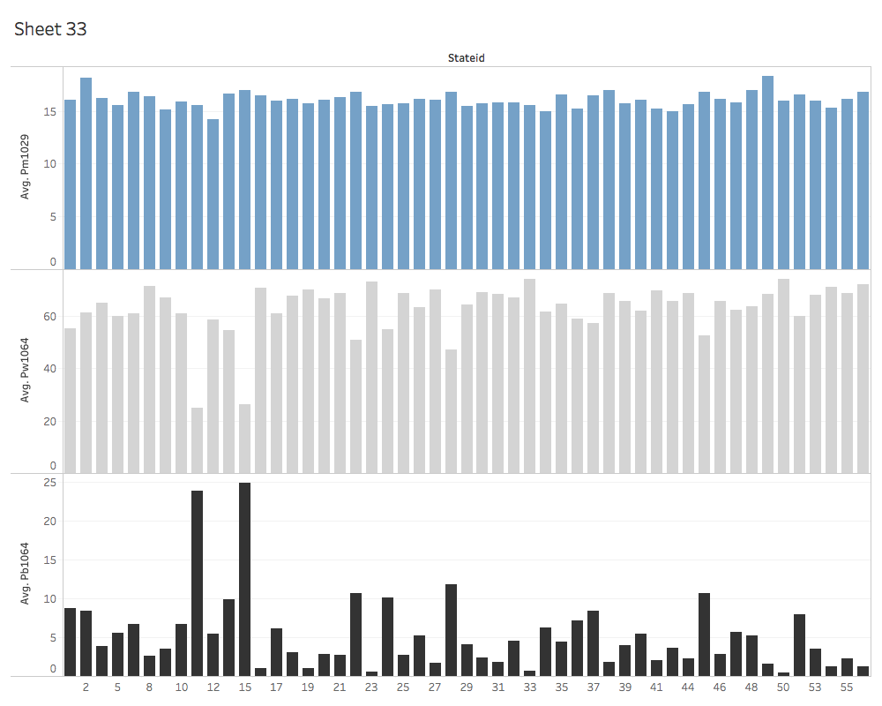

State population that is male (blue) ages 10 to 29, white (grey) ages 10 to 64 and black (black) ages 10 to 64 for the years (1977-1999)

We observe that, percent of state population that are males in year (1977-1999) is almost same in all the 51 states. The percent of state population that is black is highest in states 11 and 15.

The economic theory suggests that crime rate and percent of state population that is black are positively associated. From the above graph of average crime rates across states, we see the state 11 has the highest crime rates. Thus, % of state population that are black could be one of the reasons for very high crime rate in state 11.We can further observe the behavior of % state population on crime rate in our model outputs.

POPULATION AND DENSITY – CRIME RATE

The economic theory suggests that states with higher populations and higher density will have higher crime rates than smaller populations, and they have a bigger impact on crime rates than shall laws or incarceration rates. We created variables for above average population, below average population, above average density and below average density. We created scatter plots comparing the average crime rate to the above and below average populations. Looking at the scatterplot, we cannot conclude that population has an impact with violent crime because it is basically the same spread for each.

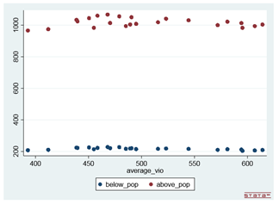

To compare density and violent crime, we divided the average violent crime per year by 10,000 to get like values. Then, we ran a scatter plot comparing the average violent crime rate per year by the average density per year. It appears there is an inverse relationship between the two. As violent crime increases, density decreases. This is opposite of what we expected, and it goes against the correlation, which is strongly positive at .66. When we think about violent crime, our intuition tells us that more violent crime occurs in densely populated areas like big city centers, but the scatter plot is showing the opposite.

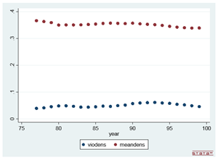

INCARCERATION RATE - CRIME RATE

Next, we decided to investigate the effect incarceration rates have on violent crime rates.

We created a new variable to find the average incarceration rate per year. Each year, incarceration rates go up:

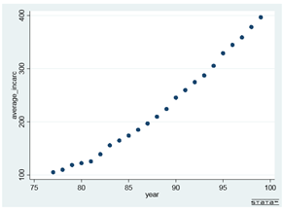

Incarceration rate and violent crime rate has a correlation of .7, so my intuition tells me that I will see a similar curve with violent crime. Next, I ran a scatter plot to compare the average incarceration rate with the average violent crime rate per year. In the graph, violent crime rate goes up and down until the mid-1990’s when it takes a steep dive down. The question is how much of the decline is due to increasing incarceration rates and how much of it is due to other factors?

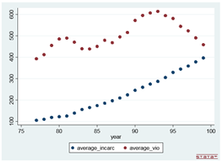

MODEL OUTPUTS

After analyzing the data, we believe that a combination of higher incarceration rates and shall laws is the best policy to lower crime rates. With the steep increase of incarceration rates and the steep decline in violent crime, murder, and robbery starting in the 1990’s for almost all states as well as the overall much lower crime rate for states with shall laws, it’s a combination of both that lead to lower crime.

To test this hypothesis – Models used are as follows:

1. **Fixed Effect Model with no time effects:**

This model included all the variables in the original data set. The results have unexpected signs and quite a few of the variables are insignificant. This is true for all three dependent variables, violent crime, murder rate, and robbery.

1. For **Violent Crime** specifically, the only variable significant at 5% is the percentage of men, and the only variable significant at 10% is the percentage of white people. Incarceration rate, percentage of men, and population have unexpected signs. Finally, the magnitude of density is extremely large compared to the rest of the variables. The output is as follows:

xtset stateid year

xtreg vio incarc_rate pb1064 pw1064 pm1029 pop density avginc i.shall, fe cluster(stateid)

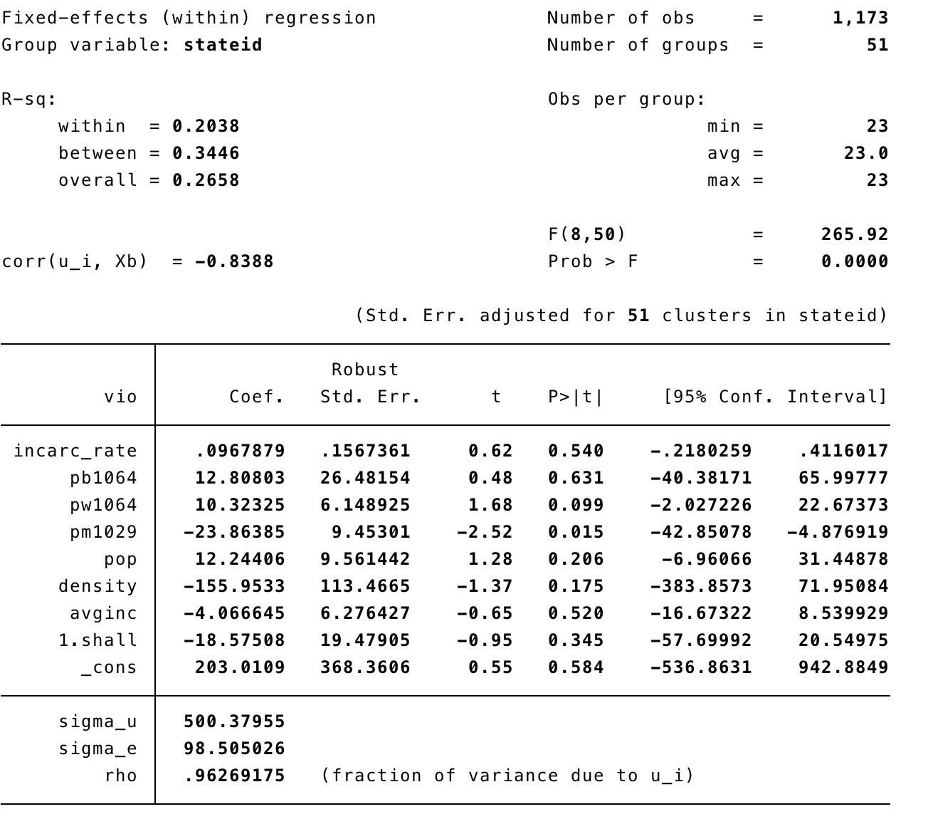

1. For **Murder**, none of the variables are significant at 5% and only average income is significant at 10%. Like violent crime, incarceration rate and average income have unexpected signs. The magnitude of density is much more reasonable compared to violent crime.

xtreg mur incarc_rate pb1064 pw1064 pm1029 pop density avginc i.shall, fe cluster(stateid)

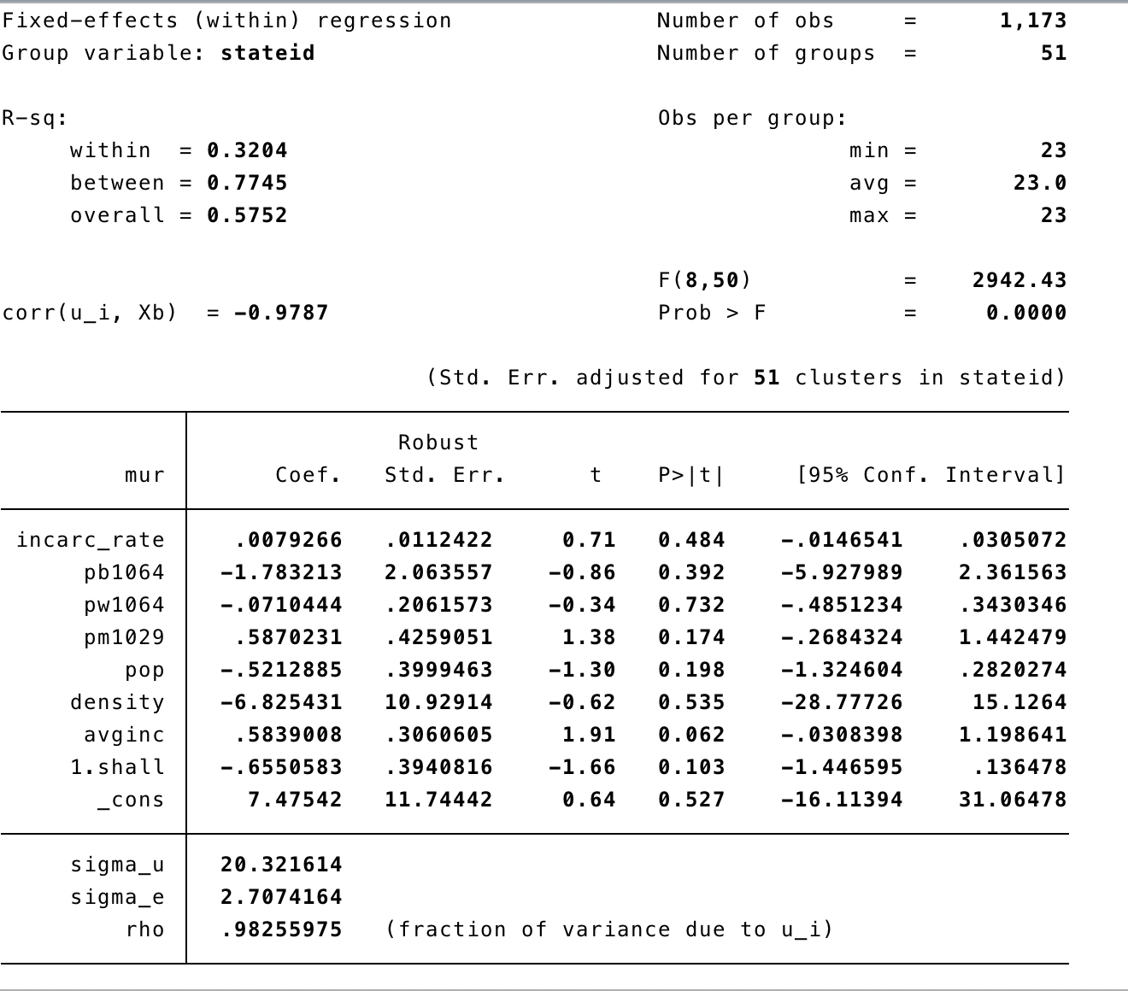

1. The model for **Robbery** is better than violent crime or murder, but several of the variables are still insignificant at 5 or 10%. But, incarceration rate is significant at 5% as well as percentage of white people, percentage of men, and average income. Shall has a positive sign, which does not seem correct, and density is once again large with an unexpected sign.

xtreg rob incarc_rate pb1064 pw1064 pm1029 pop density avginc i.shall, fe cluster(stateid)

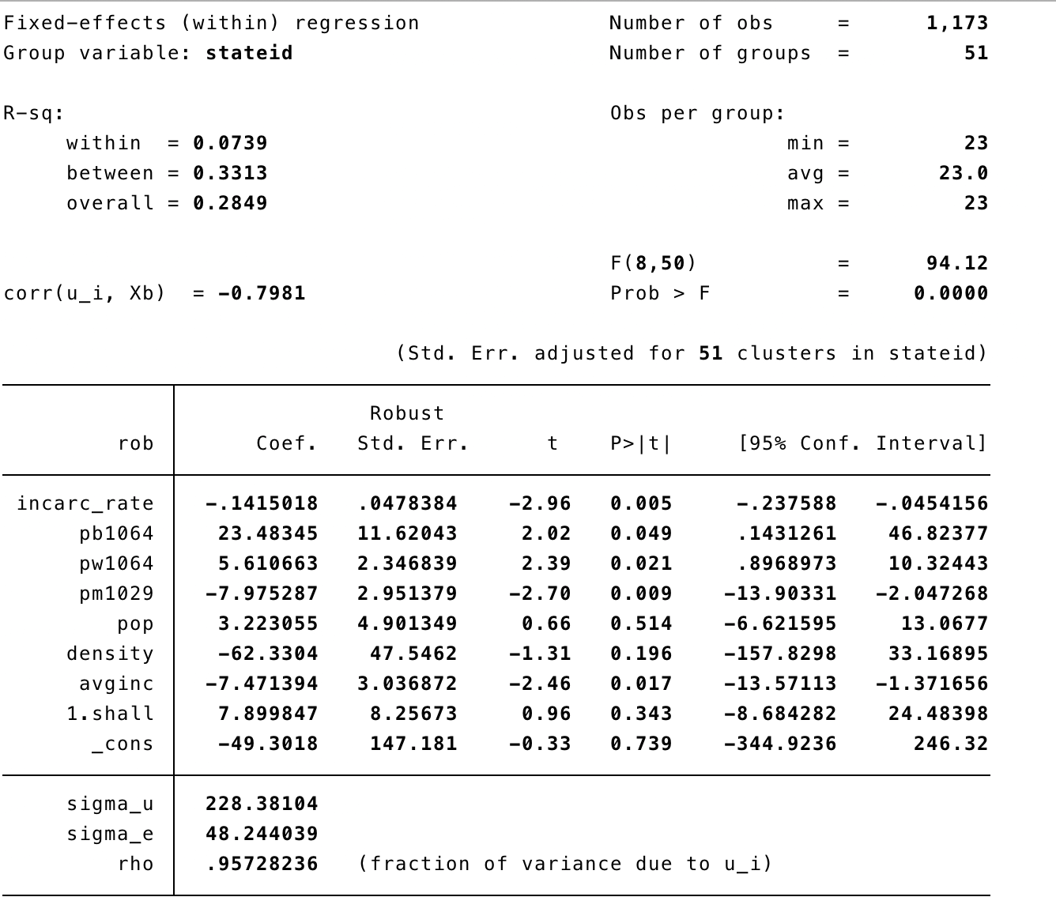

**Summary:** Overall, this model is not a good model.

1. **Fixed Effect Model with time effects:**

Next, we will account for the time effects to see if that improves the model. The model for violent crime is still bad with no significant variables, but the test for significance for the years does show we can reject the null hypothesis. This is true for murder and robbery rate as well.

1. For **Violent Crime**

**xtreg vio incarc_rate pb1064 pw1064 pm1029 pop density avginc i.shall i.year, fe vce(cluster stateid)**

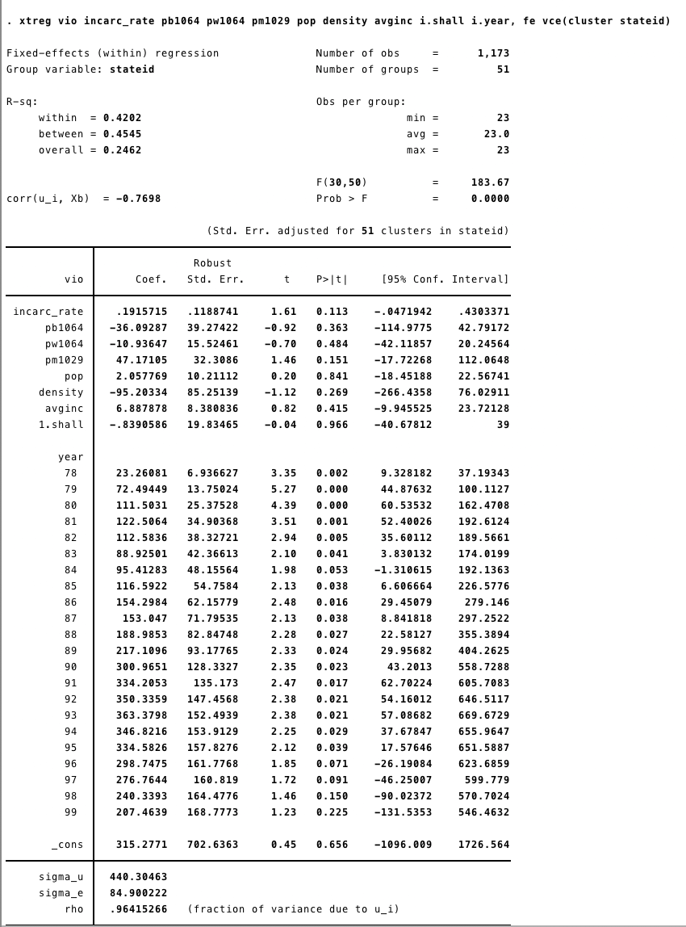

1. For **Murder**

xtreg mur incarc_rate pb1064 pw1064 pm1029 pop density avginc i.shall i.year, fe vce(cluster stateid)

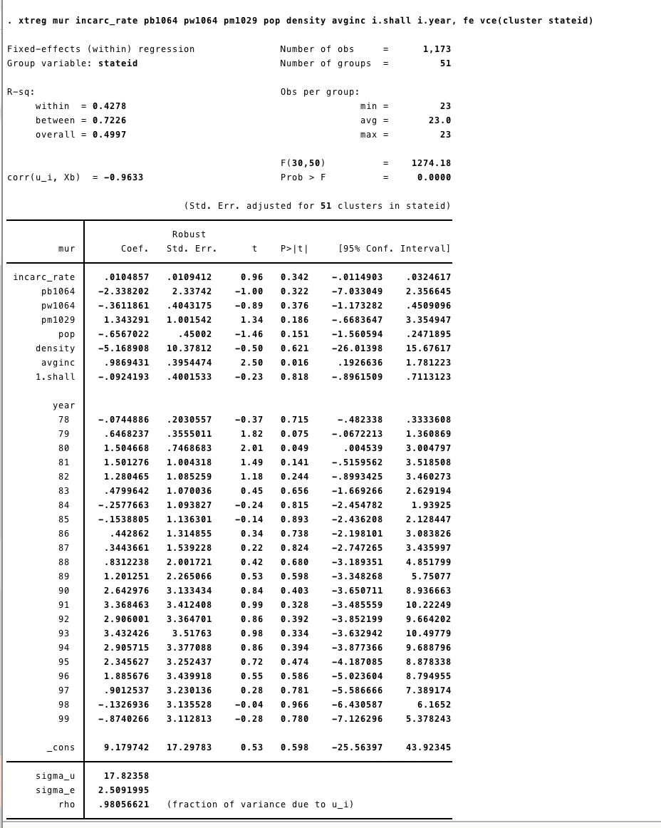

1. For **Robbery**

xtreg rob incarc_rate pb1064 pw1064 pm1029 pop density avginc i.shall i.year, fe vce(cluster stateid)

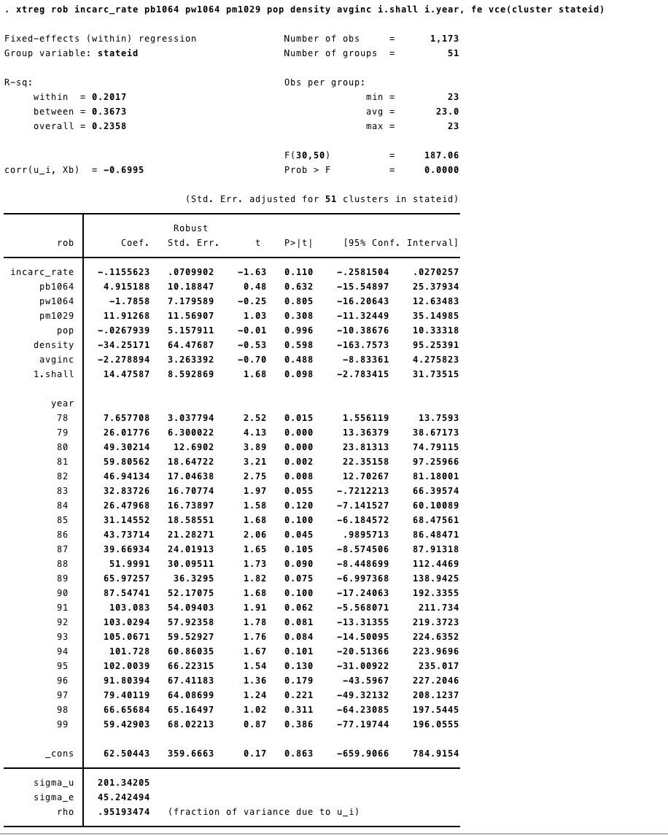

1. **Regression Adding interaction variable for incarceration rate and shall:**

The next regression we want to run is to introduce an interaction variable for incarceration rate and shall since it is our hypothesis that it is a combination of the two that will reduce crime rate the most. Simply adding the interaction variable does not work. The model is still bad with very few if any (depending on the dependent variable) variables being significant and unexpected signs and magnitudes. Shall and shall X incarceration rate are both significant at 5%, but the sign for incarceration rate, percentage of white people, percentage of men, density, average income, and shall X incarceration rate all of the wrong sign. The magnitude for density is also extreme. We see similar results with the murder and robbery rates.

1. For **Violent Crime**

xtreg vio incarc_rate pb1064 pw1064 pm1029 pop density avginc i.shall i.shall#c.incarc_rate i.year, fe vce(cluster stated

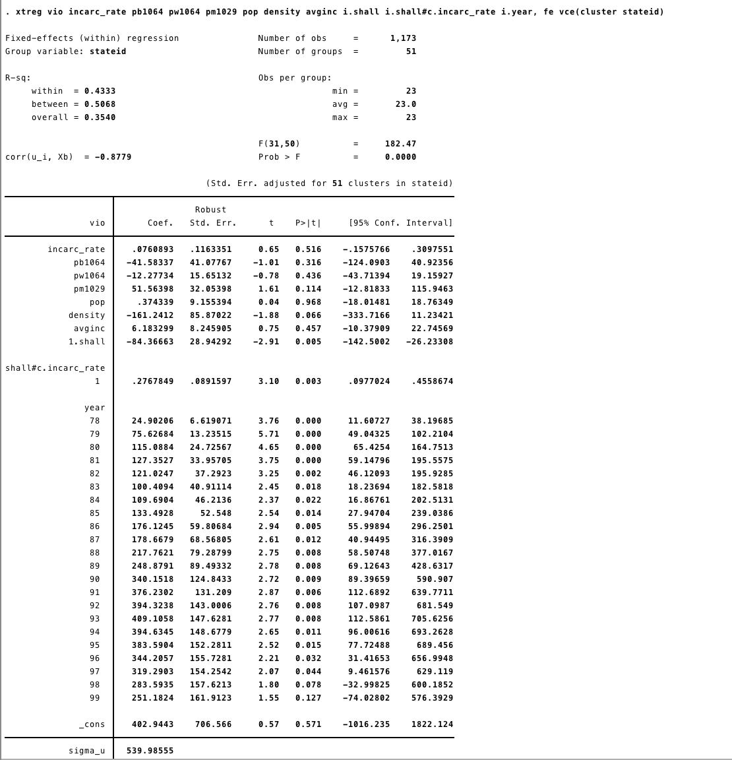

1. For **Murder**

xtreg mur incarc_rate pb1064 pw1064 pm1029 pop density avginc i.shall i.shall#c.incarc_rate i.year, fe vce(cluster stateid)

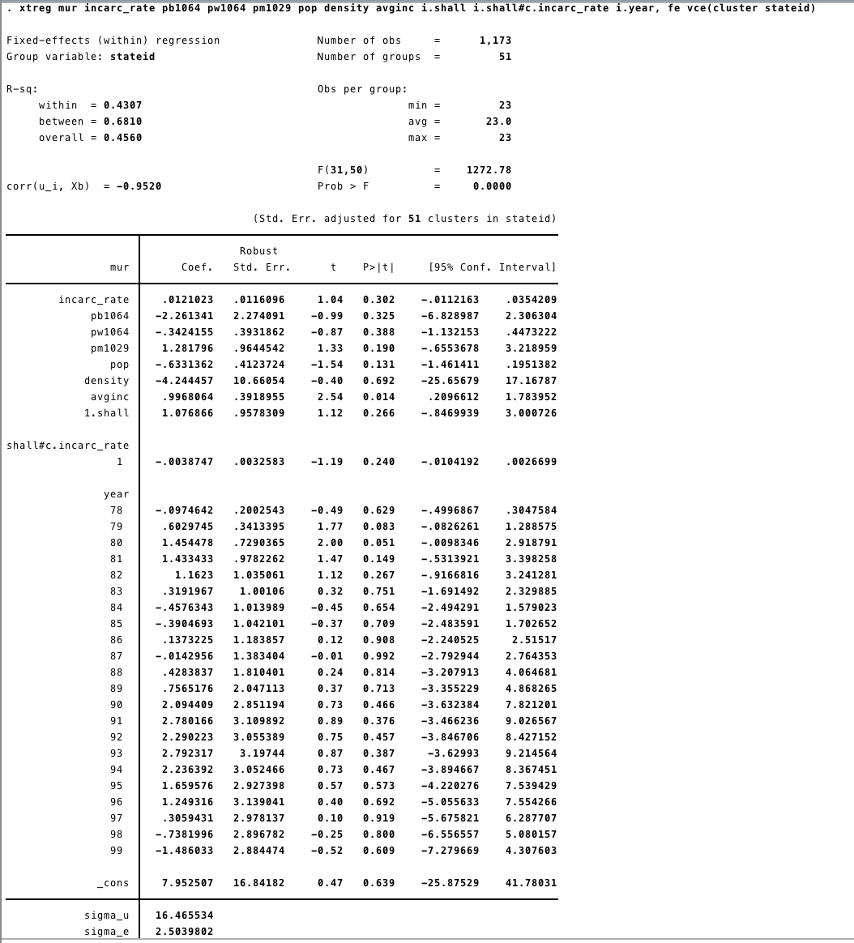

1. For **Robbery**

xtreg rob incarc_rate pb1064 pw1064 pm1029 pop density avginc i.shall i.shall#c.incarc_rate i.year, fe vce(cluster stateid)

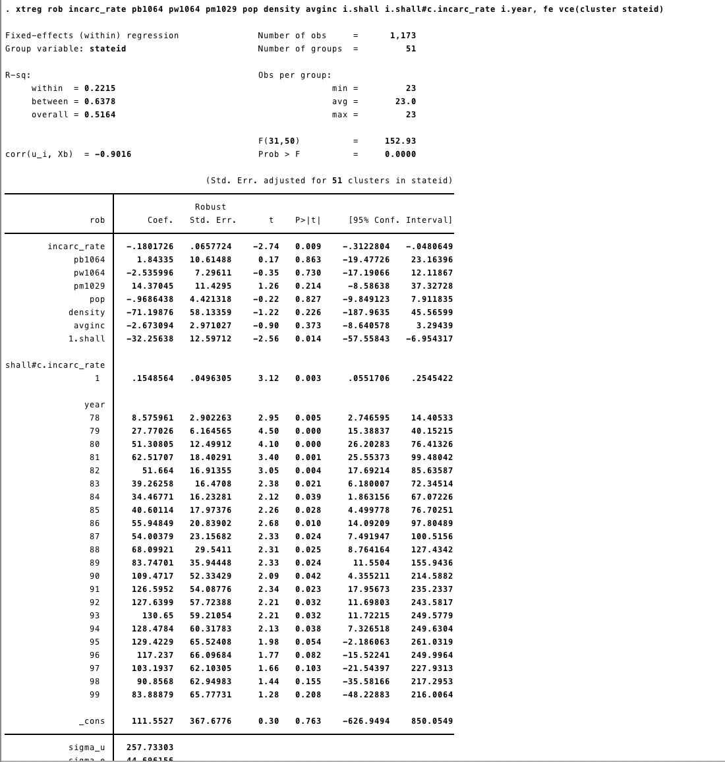

1. **Regression Adding interaction variable for incarceration rate and shall, quadratic term incarc_rate^2:**

Because the incarceration rate follows more of a curve than a straight line, we are now going to add the quadratic term incarc_rate2. Adding the variable did not do much to improve the model for violent crime. The magnitude for the variable is practically zero, and the p-value is .381. We still have few variables that are significant including shall and shallXincarc_rate, but the sign for the interaction variable is flipped. For murder, only average income is significant, and shall is positive. For robbery, density, shall, shallXincarc_rate, and incarc_rate2 are all significant, but the quadratic term is still very small, and the sign for shallXincarc_rate is wrong.

1. For **Violent crime**

xtreg vio incarc_rate pb1064 pw1064 pm1029 pop density avginc i.shall i.shall#c.incarc_rate c.incarc_rate#c.incarc_rate i.year, fe vce(cluster stateid)

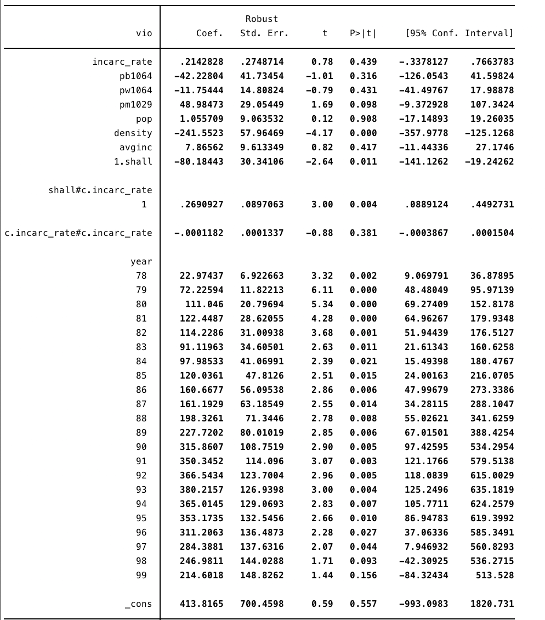

1. For **Murder**

xtreg mur incarc_rate pb1064 pw1064 pm1029 pop density avginc i.shall i.shall#c.incarc_rate c.incarc_rate#c.incarc_rate i.year, fe vce(cluster stateid)

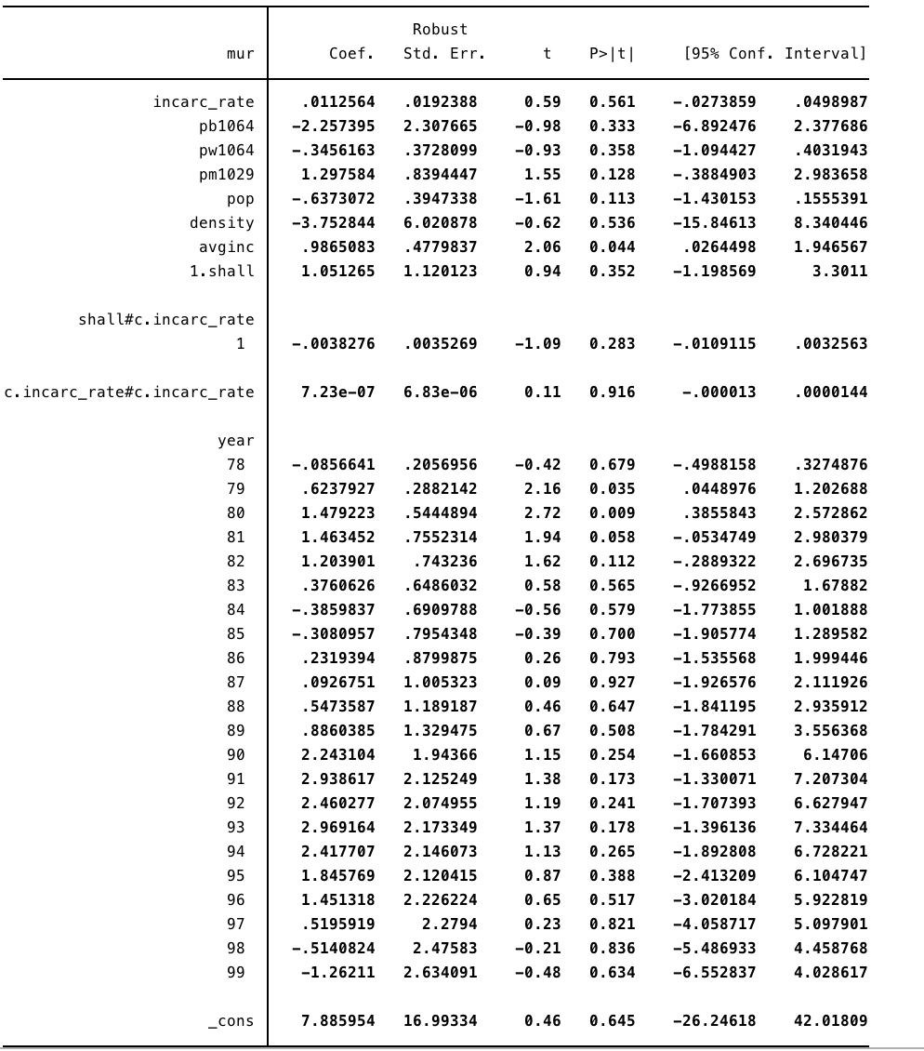

1. For **Robbery**

xtreg rob incarc_rate pb1064 pw1064 pm1029 pop density avginc i.shall i.shall#c.incarc_rate c.incarc_rate#c.incarc_rate i.year, fe vce(cluster stateid)

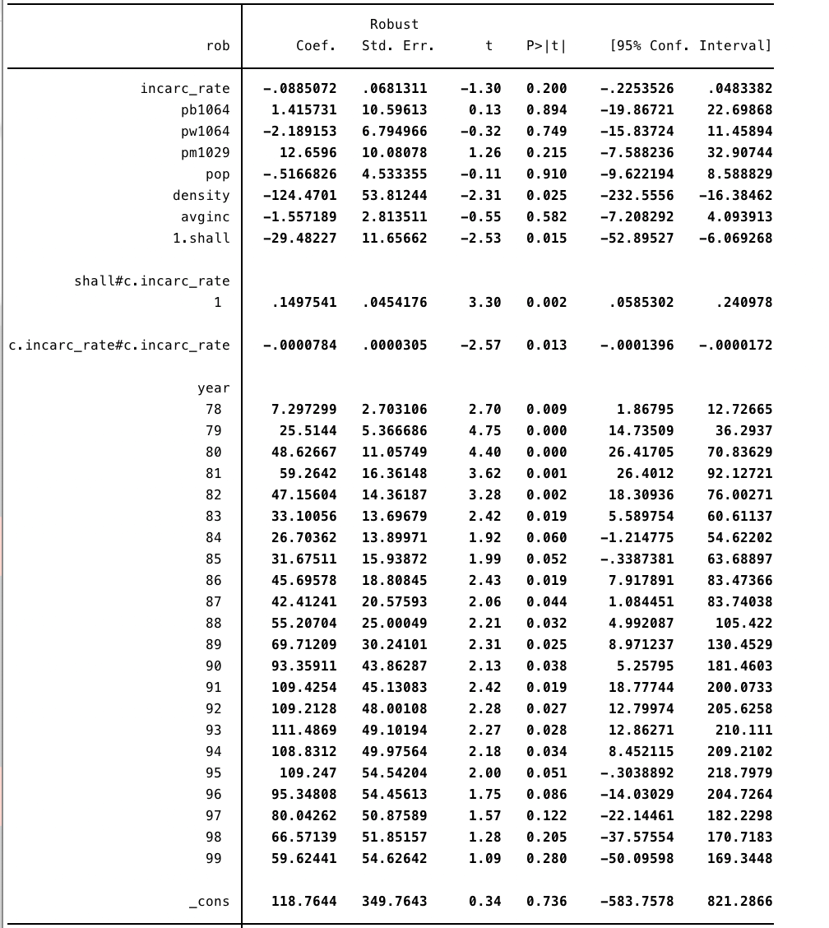

1. **Further Regressions by removing variables:**

* It is now time to start removing variables. We are going to start with the interaction variable. The variable incarc_rate2 is still practically zero for all three dependent variables, and the model got worse with fewer significant variables when compared to the full model.
* We are going to add incarc_rate2 back into the model and remove the percent of the population that is white and the percent of the population that is black. Again, the model was not improved by removing these variables.
* We are going to add the variables back into the model and see what adding the interaction variable popXdensity does to the model. We chose this variable because intuitively, it seems logical that they will affect each other. The model is worse, so the intuition is probably not sound.
* Because the model is worse, we are going to remove the new interaction variable along with pop. We are also going to remove the incarceration rate squared variable as the magnitudes continue to be extremely low. We are also going to run the regression without the shall X incarceration rate variable to see if there is a difference between the two. The model that includes the interaction variable is better than the model that does not. It has lower p-value for shall, and the p-value for the interaction variable is also significant. This model is also an improvement over the model that included pop and incarceration rate squared. It is still not good, and we need to continue looking for a better model. Moving forward, we will include the interaction variable shall X incarceration until we find a reason to remove it.
* Next, we are going to remove the percent of the population that is white and the percent that is black. This is by far the best model so far. For violent crime, incarceration rate and average income are still insignificant, and the signs are wrong. For murder, the model continues to be bad with average income being the only significant variable.  For robbery, density and average income are insignificant, and their signs are wrong. Although the model is the best one so far, it is still not sufficient to draw good conclusions.
* Now, we are going to remove the percentage of males. The model was not improved.
* Because the percentage of white people and the percentage of black people have a correlation of almost -1 (-.9), we are going to add the percentage of black people back into the model along with population and percentage of men. The model is not much improved.
* We are going to add back in all of the population variables and remove density. Incarceration, shall, and shall X incarceration are all significant. But, incarceration rate, percentage of black people, percentage of male, and population all of the wrong sign. Because the three variables of interest are all significant, this model appears to be headed in the right direction, but it is still not good.
* We are going to remove the three percents of population variables, which leaves just incarceration rate, average income, shall, and shall X incarceration rate. The result for robbery and murder both have significant variables for everything except average income. Shall is also insignificant for violent crime. This is the best model so far, so the next step is to remove average income.
* Removing average income leads to the best result. For all three dependent variables, all of the explanatory variables are significant at 5% with the exception of shall for violent crime, which is still significant at 10%. Incarceration rate is positive for violent crime and murder, but it is negative for robbery.

1. **Final regression Model:**

The best model we could find only included variables dealing with incarceration rates and shall laws. We believe, though, that this model is suffering from omitted variable bias. Intuitively, we feel that some other variables must be affecting crime rates that we do not have.

1. For **Violent Crime**

xtreg vio incarc_rate i.shall i.year, fe vce(cluster stateid)

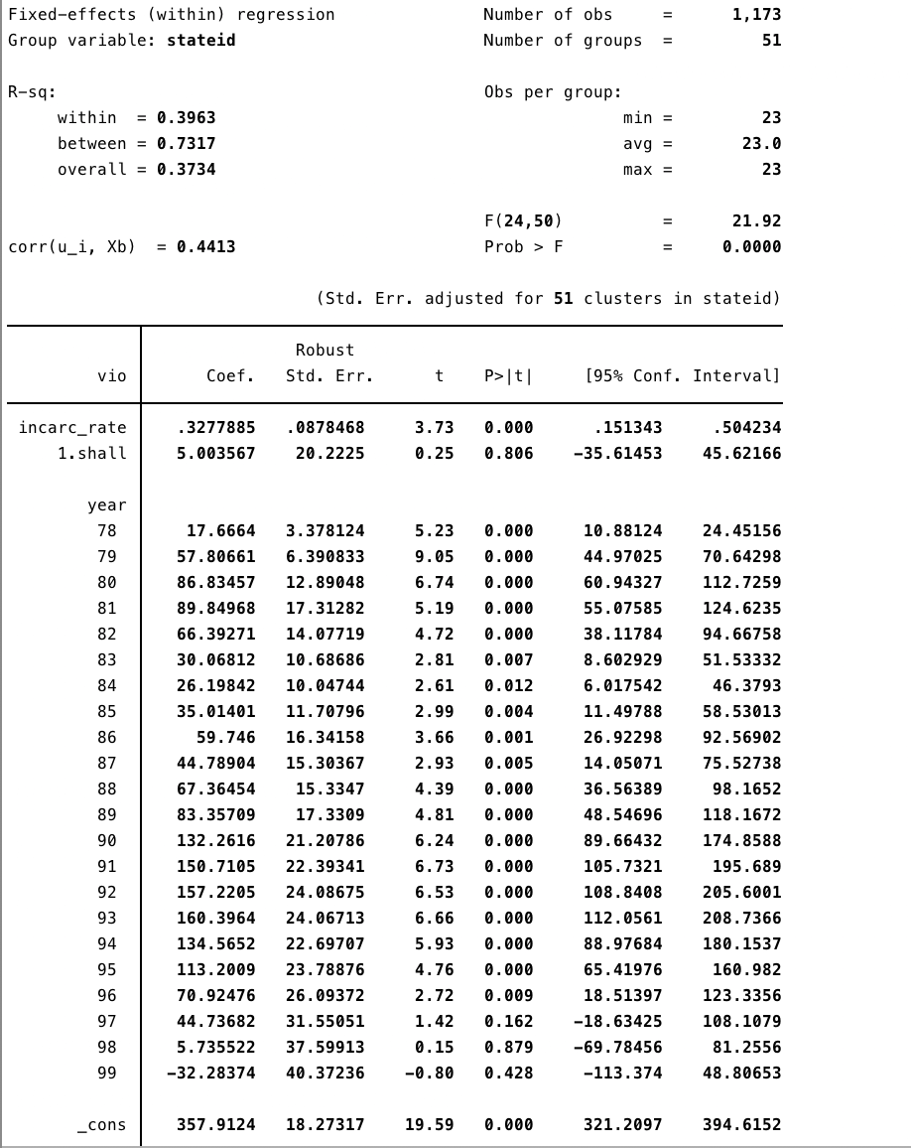

1. For **Murder**

xtreg mur incarc_rate i.shall i.year, fe vce(cluster stateid)

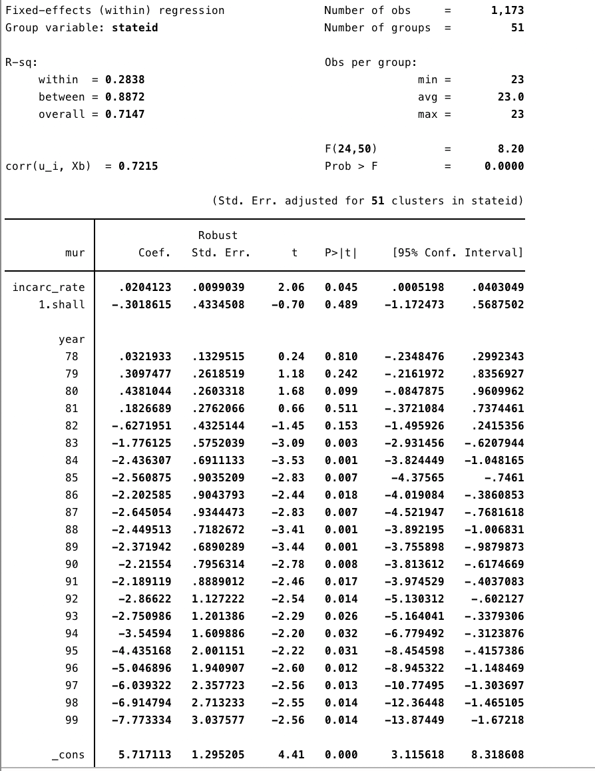

1. For **Robbery**

xtreg rob incarc_rate i.shall i.year, fe vce(cluster stateid)

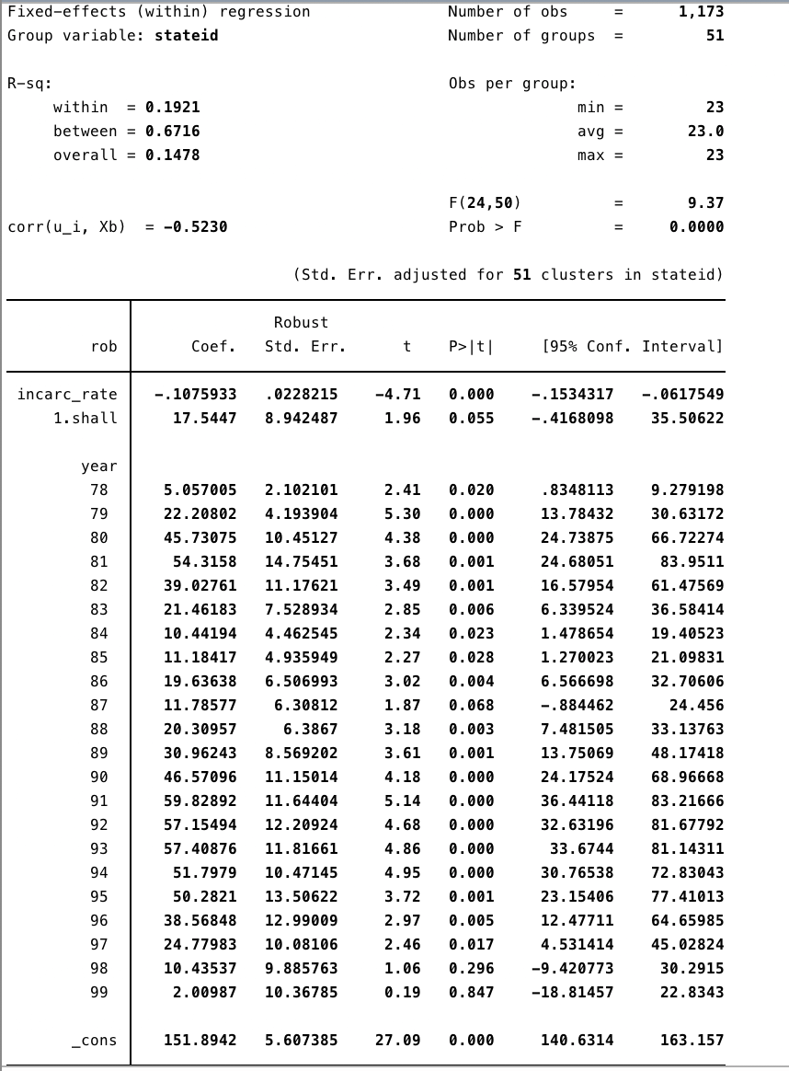

CONCLUSION

Based on our exploratory analysis and model outputs, Within Fixed Effects is the best fit model for the given panel data. Because all of our models were either very bad or suffering from omitted variable bias, we cannot conclude that adoption of shall law or increasing incarceration rates are truly effective at decreasing crime rates from the given data. The correct magnitude of impact of Shall-Law and the Incarceration rate cannot be obtained from the given data.